Please visit https://medium.com/@adiramadhan17/class-based-view-crud-django-with-bootstraptemplate-b241600ee021
For more.

Django CRUD with Forms and Bootstrap Template


Adi Ramadhan

Jul 21·3 min read
Simple function based view Django CRUD with Django Forms and Bootstrap template.

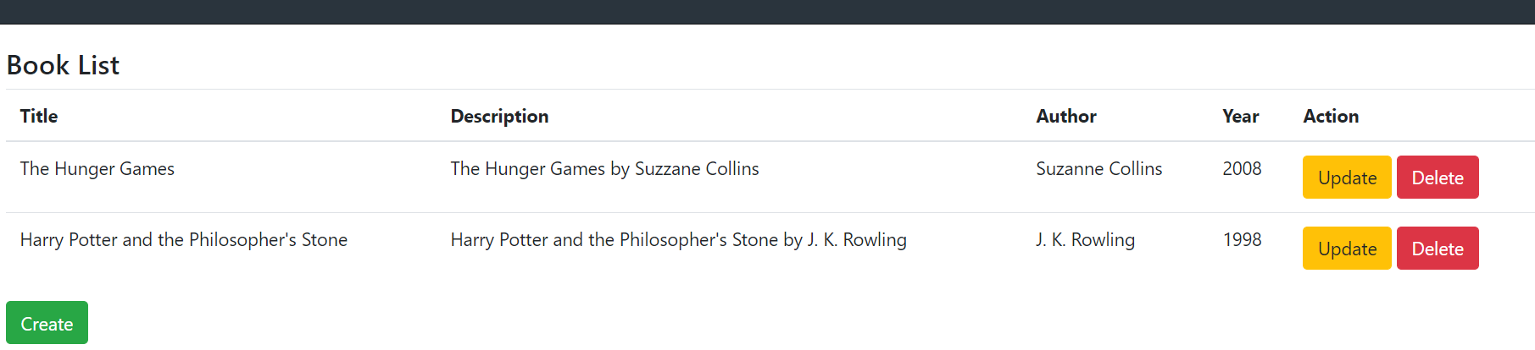Django Forms Official docs here.
Step 1: Preparation, Create Django Project, Initial Migration
create virtualenv: virtualenv venv
start virtualenv: venv/Scripts/activate
install Django in virtualenv: pip install django==3.0
Create Django: django-admin startproject myproject
Go to myproject folder: cd myproject
Initial Migration: python manage.py migrateStep 2: Create Django Apps
Create apps: python manage.py startapp myapp
Add myapp to INSTALLED_APPS in myproject/settings.py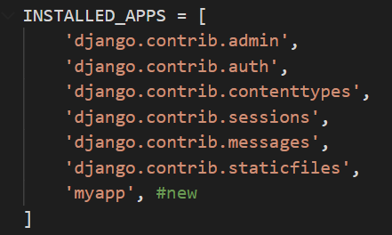
Step 3: Set up Templates Folder
Create folder templates in myapp

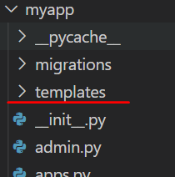
Add template directory in TEMPLATES parameter in myproject/settings.py
os.path.join(BASE_DIR, 'myapp', 'templates')

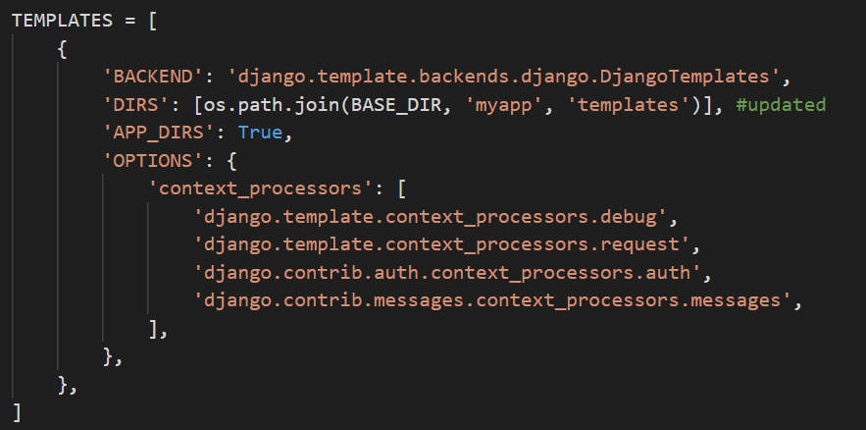
Step 4: Create Model in myapp, Makemigrations and Migrate
Add Book Model in myapp/models.py
from django.db import models
# Create your models here.
class Book(models.Model):
title = models.CharField(db_column='title', max_length=100, blank=False)
description = models.TextField(db_column='description', max_length=1000, blank=False)
author = models.CharField(db_column='author', max_length=100, blank=False)
year = models.IntegerField(db_column='year',blank=False, default=2000)

Make migrations: python manage.py makemigrations
Migrate: python manage.py migrate
Step 5: Create HTML Files in myapp/templates Folder
Create bootstrap base, create myapp/templates/base.html CDN Bootstrap.
<html lang="en">
<head>
<title>{% block title %}{% endblock %}</title>
<!-- CSS only -->
<link rel="stylesheet" href="https://stackpath.bootstrapcdn.com/bootstrap/4.5.0/css/bootstrap.min.css"
integrity="sha384-9aIt2nRpC12Uk9gS9baDl411NQApFmC26EwAOH8WgZl5MYYxFfc+NcPb1dKGj7Sk" crossorigin="anonymous">
<!-- JS, Popper.js, and jQuery -->
<script src="https://code.jquery.com/jquery-3.5.1.slim.min.js"
integrity="sha384-DfXdz2htPH0lsSSs5nCTpuj/zy4C+OGpamoFVy38MVBnE+IbbVYUew+OrCXaRkfj"
crossorigin="anonymous"></script>
<script src="https://cdn.jsdelivr.net/npm/popper.js@1.16.0/dist/umd/popper.min.js"
integrity="sha384-Q6E9RHvbIyZFJoft+2mJbHaEWldlvI9IOYy5n3zV9zzTtmI3UksdQRVvoxMfooAo"
crossorigin="anonymous"></script>
<script src="https://stackpath.bootstrapcdn.com/bootstrap/4.5.0/js/bootstrap.min.js"
integrity="sha384-OgVRvuATP1z7JjHLkuOU7Xw704+h835Lr+6QL9UvYjZE3Ipu6Tp75j7Bh/kR0JKI"
crossorigin="anonymous"></script>
</head>
<body>
{% block content %}
{% endblock %}
</body>
</html>
Create book-list template, myapp/templates/book-list.html
{% extends "base.html" %}
{% block content %}
<div class="card-body">
<h4>Book List</h4>
<table class="table">
<thead>
<tr>
<th scope="col">Title</th>
<th scope="col">Description</th>
<th scope="col">Author</th>
<th scope="col">Year</th>
<th scope="col">Action</th>
</tr>
</thead>
<tbody>
{% for book in books %}
<tr>
<td>{{ book.title }}</td>
<td>{{ book.description }}</td>
<td>{{ book.author }}</td>
<td>{{ book.year }}</td>
<td><a type="button" class="btn btn-warning" href="/book-update/{{ book.id }}">Update</a>
<a type="button" class="btn btn-danger" href="/book-delete/{{ book.id }}">Delete</a>
</td>
</tr>
{% endfor %}
</tbody>
</table>
<a type="button" class="btn btn-success" href="{%url 'book-create' %}">Create</a>
</div>
{% endblock %}

Create book-create template, myapp/templates/book-create.html

{% extends "base.html" %}
{% block content %}
<div class="card-body">
<h5>Create New Book</h5>
<form method="post">
{% csrf_token %}
{{form.as_p}}
<a type="button" class="btn btn-danger" href="{%url 'book-list' %}">Cancel</a>
<button type="submit" class="btn btn-success">Create</button>
</form>
</div>
{% endblock %}

Create book-update template, myapp/templates/book-update.html
{% extends "base.html" %}
{% block content %}
<div class="card-body">
<h4>Update Book</h4>
<form method="post">
{% csrf_token %}
{{form.as_p}}
<a type="button" class="btn btn-danger" href="{%url 'book-list' %}">Cancel</a>
<button type="submit" class="btn btn-success">Update</button>
</form>
</div>
{% endblock %}

Step 6: Create Forms.py in myapp Folder
Create forms in myapp, myapp/forms.py
from django.forms import ModelForm
from .models import Book
class BookForm(ModelForm):
class Meta:
model = Book
fields = '__all__'
Step 7: Create Function Based View in myapp/views.py
Update myapp/views.py. Add Function Based View method that render html file and using BookForm.
from django.shortcuts import render, redirect
from .models import Book
from .forms import BookForm
# Create your views here.
def bookList(request):
books = Book.objects.all()
return render(request,"book-list.html",{'books':books})
def bookCreate(request):
if request.method == "POST":
form = BookForm(request.POST)
if form.is_valid():
try:
form.save()
model = form.instance
return redirect('book-list')
except:
pass
else:
form = BookForm()
return render(request,'book-create.html',{'form':form})
def bookUpdate(request, id):
book = Book.objects.get(id=id)
form = BookForm(initial={'title': book.title, 'description': book.description, 'author': book.author, 'year': book.year})
if request.method == "POST":
form = BookForm(request.POST, instance=book)
if form.is_valid():
try:
form.save()
model = form.instance
return redirect('/book-list')
except Exception as e:
pass
return render(request,'book-update.html',{'form':form})
def bookDelete(request, id):
book = Book.objects.get(id=id)
try:
book.delete()
except:
pass
return redirect('book-list')

Step 8: Setup URLs in myapp and myproject Folder
Create myapp/urls.py
from . import views
from django.urls import path
urlpatterns = [
path('book-list', views.bookList, name='book-list'),
path('book-create', views.bookCreate, name='book-create'),
path('book-update/<int:id>', views.bookUpdate, name='book-update'),
path('book-delete/<int:id>', views.bookDelete, name='book-delete'),
]

Update myproject/urls.py
from django.contrib import admin
from django.urls import path, include
urlpatterns = [
path('admin/', admin.site.urls),
path('', include('myapp.urls')) #new
]

Step 9: Run Server and Testing
Run Server: python manage.py runserver
Testing: http://127.0.0.1:8000/book-list
Try to Create, Update, and Delete

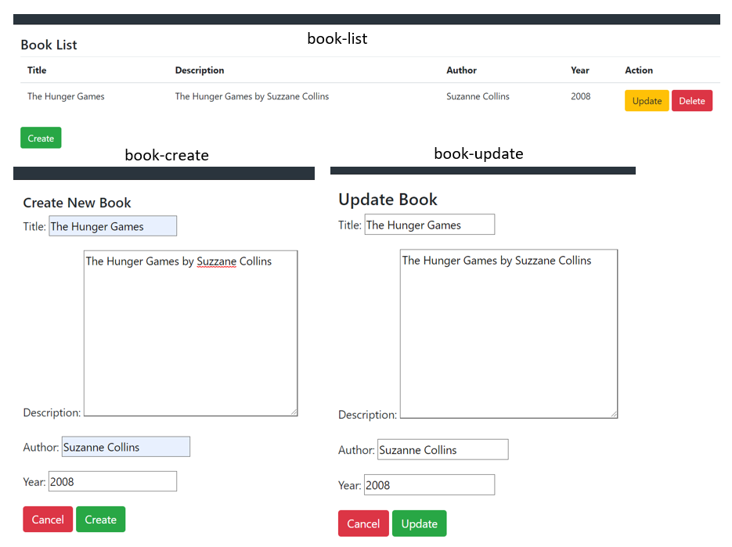
Summarized Section
Step 1: Preparation, Create Django Project, Initial Migration
create virtualenv: virtualenv venv
start virtualenv: venv/Scripts/activate
install Django in virtualenv: pip install django==3.0
Create Django: django-admin startproject myproject
Go to myproject folder: cd myproject
Initial Migration: python manage.py migrate
Step 2: Create Django Apps
Create apps: python manage.py startapp myapp
Add myapp to INSTALLED_APPS in myproject/settings.py
Step 3: Set up Templates Folder
Create folder templates in myapp
Add template directory in TEMPLATES parameter in myproject/settings.py
os.path.join(BASE_DIR, 'myapp', 'templates')
Step 4: Create Model in myapp, Makemigrations and Migrate
Add Book Model in myapp/models.py
Make migrations: python manage.py makemigrations
Migrate: python manage.py migrate
Step 5: Create HTML Files in myapp/templates Folder
Create bootstrap base, create myapp/templates/base.html CDN Bootstrap.
Create book-list.html, book-create.html, book-update.html
Step 6: Create Forms.py in myapp Folder
Create forms in myapp, myapp/forms.py
Step 7: Create Function Based View in myapp/views.py
Update myapp/views.py. Add Function Based View method that render html file and using BookForm.
Step 8: Setup URLs in myapp and myproject Folder
Create myapp/urls.py
Update myproject/urls.py
Step 9: Run Server and Testing
Run Server: python manage.py runserver
Testing: http://127.0.0.1:8000/book-list
Try to Create, Update, and Delete
- Django
- Python
- Web Development

Class Based View CRUD Django with BootstrapTemplate
Basic Class Based View CRUD Django with Bootstrap Template. Django Official docs here.

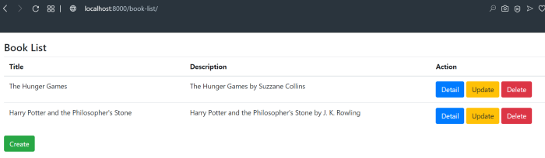
Step 1: Preparation, Create Django Project, Initial Migration
install virtualenv: pip install virtualenv
create virtualenv: virtualenv venv
start virtualenv: venv/Scripts/activate
install Django in virtualenv: pip install django
Create Django: django-admin startproject myproject
Go to myproject folder: cd myproject
Initial Migration: python manage.py migrate
Step 2: Create Django Apps
Create apps: python manage.py startapp myapp
Add myapp to INSTALLED_APPS in myproject/settings.py

Step 3: Set up Templates Folder
Create folder templates in myapp
Add template directory in TEMPLATES parameter in myproject/settings.py
os.path.join(BASE_DIR, 'myapp', 'templates')
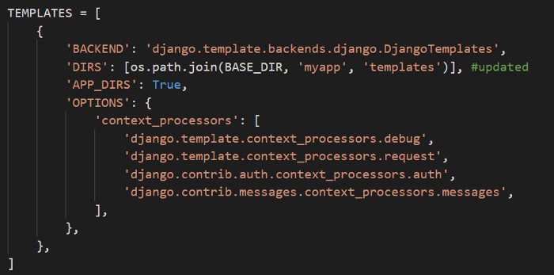
Step 4: Create Model in myapp, Makemigrations and Migrate
Add Book Model in myapp/models.py …

Django Rest Framework Basic Authentication
Create DRF REST API with Basic Authentication.
Official docs here.

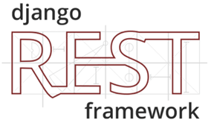
Step 1: Preparation, Create Django Project, Initial Migration
Install virtualenv: pip install virtualenv
Create virtualenv: virtualenv venv
Start virtualenv: venv/Scripts/activate
Install Django, DRF in virtualenv: pip install django djangorestframework
Create Django: django-admin startproject myproject
Go to myproject folder: cd myproject
Initial Migration: python manage.py migrate
Create superuser: python manage.py createsuperuser
(for example: username=admin)
Step 2: Create App
Create app: python manage.py createapp myapp
Create API in myapp/views.py

from rest_framework.views import APIView
from rest_framework.response import Response
from rest_framework.authentication import BasicAuthentication
from rest_framework.permissions import IsAuthenticated
class HelloView(APIView):
authentication_classes = [BasicAuthentication]
permission_classes = [IsAuthenticated]
def get(self, request):
content = {'message': 'Hello World!'}
return Response(content)

Step 3: Set up urls
Create myapp/urls.py
from django.urls import path
from . import views
urlpatterns = [
path('hello/', views.HelloView.as_view(), name='hello'),
]

Update myproject/urls.py

from django.contrib import admin
from django.urls import path, include #updated
urlpatterns = [
path('admin/', admin.site.urls),
path('', include('myapp.urls')) #new
]

Step 4: Settings.py
Register myapp and rest_framework in INSTALLED_APPS
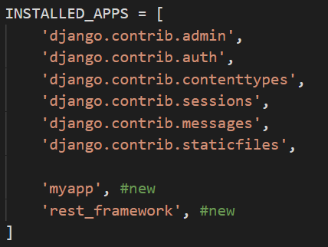
Step 6: Testing
Run server: python manage.py runserver
Test call API using POSTMAN. Download and see official docs here.
http://127.0.0.1:8000/hello/ with Basic Auth with user that created before (see Step 1),

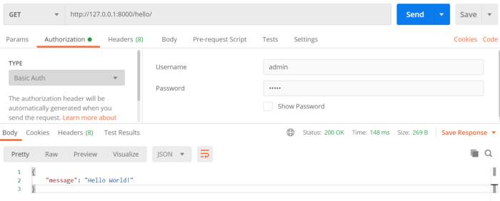

Django Rest Framework Token Authentication
Create DRF REST API with Token Authentication.
Official docs here.

Step 1: Preparation, Create Django Project, Initial Migration
Install virtualenv: pip install virtualenv
Create virtualenv: virtualenv venv
Start virtualenv: venv/Scripts/activate
Install Django, DRF in virtualenv: pip install django djangorestframework
Create Django: django-admin startproject myproject
Go to myproject folder: cd myproject
Initial Migration: python manage.py migrate
Create superuser: python manage.py createsuperuser
(for example: username=admin)
Step 2: Create App
Create app: python manage.py createapp myapp
Create API in myapp/views.py

from rest_framework.views import APIView
from rest_framework.response import Response
from rest_framework.authentication import BasicAuthentication
from rest_framework.permissions import IsAuthenticated
class HelloView(APIView):
authentication_classes = [BasicAuthentication]
permission_classes = [IsAuthenticated]
def get(self, request):
content = {'message': 'Hello World!'}
return Response(content)

Step 3: Set up urls
Create myapp/urls.py

from django.urls import path
from . import views
urlpatterns = [
path('hello/', views.HelloView.as_view(), name='hello'),
]
Update myproject/urls.py

from django.contrib import admin
from django.urls import path, include #updated
urlpatterns = [
path('admin/', admin.site.urls),
path('', include('myapp.urls')) #new
]
Step 4: Settings.py
Register myapp, rest_framework and rest_framework.authtoken in INSTALLED_APPS

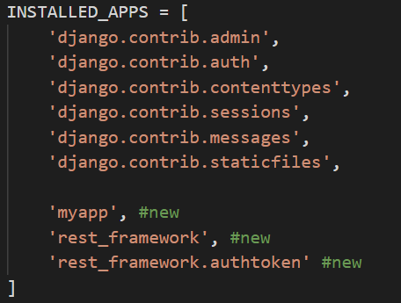
Step 6: Testing
Run server: python manage.py runserver
Test call API using POSTMAN. Download and see official docs here.
http://127.0.0.1:8000/hello/ with Basic Auth with user that created before (see Step 1),

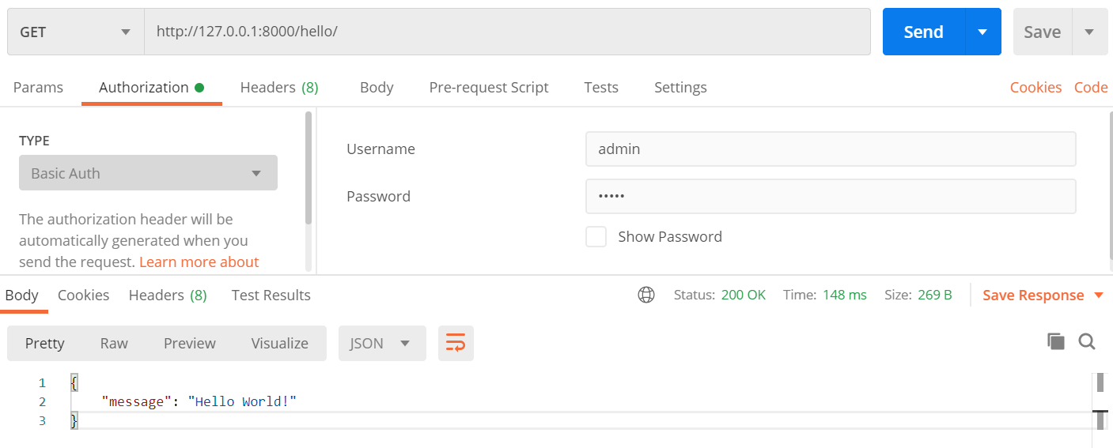
- Django
- Django Rest Framework
- Web Development
- Python

Django Rest Framework Token Authentication
Create DRF REST API with Token Authentication.
Official docs here.

Step 1: Preparation, Create Django Project, Initial Migration
Install virtualenv: pip install virtualenv
Create virtualenv: virtualenv venv
Start virtualenv: venv/Scripts/activate
Install Django, DRF in virtualenv: pip install django djangorestframework
Create Django: django-admin startproject myproject
Go to myproject folder: cd myproject
Initial Migration: python manage.py migrate
Create superuser: python manage.py createsuperuser
(for example: username=admin)
Step 2: Create App
Create app: python manage.py createapp myapp
Create API in myapp/views.py

from rest_framework.views import APIView
from rest_framework.response import Response
from rest_framework.authentication import TokenAuthentication
from rest_framework.permissions import IsAuthenticated
class HelloView(APIView):
authentication_classes = [TokenAuthentication]
permission_classes = [IsAuthenticated]
def get(self, request):
content = {'message': 'Hello World!'}
return Response(content)
Step 3: Set up urls
Create myapp/urls.py

from django.urls import path
from . import views
urlpatterns = [
path('hello/', views.HelloView.as_view(), name='hello'),
]
Update myproject/urls.py

from django.contrib import admin
from django.urls import path, include #updated
urlpatterns = [
path('admin/', admin.site.urls),
path('', include('myapp.urls')) #new

]

Step 4: Settings.py
Register myapp, rest_framework and rest_framework.authtoken in INSTALLED_APPS

Add REST_FRAMEWORK in myproject/settings.py

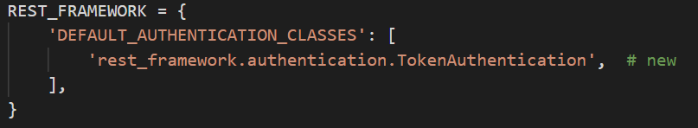
REST_FRAMEWORK = {
'DEFAULT_AUTHENTICATION_CLASSES': [
'rest_framework.authentication.TokenAuthentication', # new
],
}
Step 5: Migrate
Migrate rest framework model: python manage.py migrate
Step 6: Testing
Generate token for user admin for testing purpose:
python manage.py drf_create_token admin

Run server: python manage.py runserver
Test call API using POSTMAN. Download and see official docs here.
http://127.0.0.1:8000/hello/
Header
Authorization: Token <token>

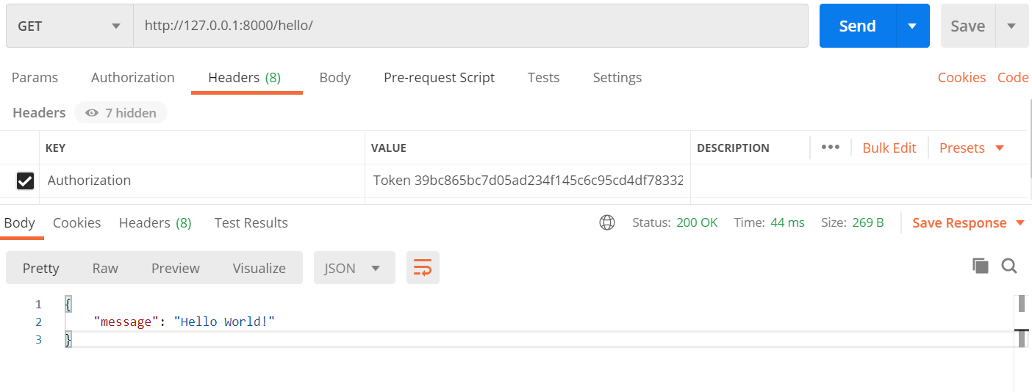
Django Admin Custom Login Page
Rendering django admin login page with customized html file (with bootstrap).

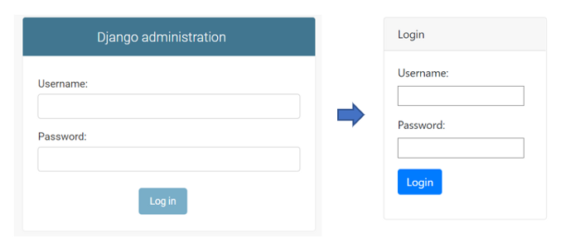
Step 1: Preparation, Create Django Project, Initial Migration
Install virtualenv: pip install virtualenv
Create virtualenv: virtualenv venv
Start virtualenv: venv/Scripts/activate
Install Django in virtualenv: pip install django
Create Django: django-admin startproject myproject
Go to myproject folder: cd myproject
Initial Migration: python manage.py migrate
Create superuser: python manage.py superuser
Step 2: Preparing Template and HTML files
Create templates folder, base.html, login.html
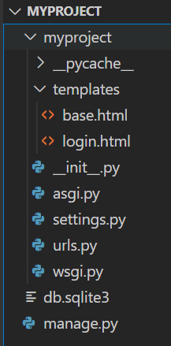

<html lang="en">
<head>
<title>{% block title %}{% endblock %}</title>
<!-- CSS only -->
<link rel="stylesheet" href="https://stackpath.bootstrapcdn.com/bootstrap/4.5.0/css/bootstrap.min.css"
integrity="sha384-9aIt2nRpC12Uk9gS9baDl411NQApFmC26EwAOH8WgZl5MYYxFfc+NcPb1dKGj7Sk" crossorigin="anonymous">
<!-- JS, Popper.js, and jQuery -->
<script src="https://code.jquery.com/jquery-3.5.1.slim.min.js"
integrity="sha384-DfXdz2htPH0lsSSs5nCTpuj/zy4C+OGpamoFVy38MVBnE+IbbVYUew+OrCXaRkfj"
crossorigin="anonymous"></script>
<script src="https://cdn.jsdelivr.net/npm/popper.js@1.16.0/dist/umd/popper.min.js"
integrity="sha384-Q6E9RHvbIyZFJoft+2mJbHaEWldlvI9IOYy5n3zV9zzTtmI3UksdQRVvoxMfooAo"
crossorigin="anonymous"></script>
<script src="https://stackpath.bootstrapcdn.com/bootstrap/4.5.0/js/bootstrap.min.js"
integrity="sha384-OgVRvuATP1z7JjHLkuOU7Xw704+h835Lr+6QL9UvYjZE3Ipu6Tp75j7Bh/kR0JKI"
crossorigin="anonymous"></script>
</head>
<body>
{% block content %}
{% endblock %}
</body>
</html>
templates/base.html

{% extends 'base.html' %}
{% block title %} Login {% endblock %}
{% block content %}
<div class="container">
<div class="card mt-5" style="width: 15rem;">
<div class="card-header">Login</div>
<div class="card-body">
<form class="form" role="form" method="POST">
{% csrf_token %}
{{ form.as_p }}
<button type="submit" class="btn btn-primary">Login</button>
</form>
</div>
</div>
</div>
</div>
{% endblock %}
templates/login.html

Step 3: Setup settings.py
Add template folder in TEMPLATES parameter in myproject/settings.py
'DIRS': [os.path.join(BASE_DIR, 'myproject', 'templates')],

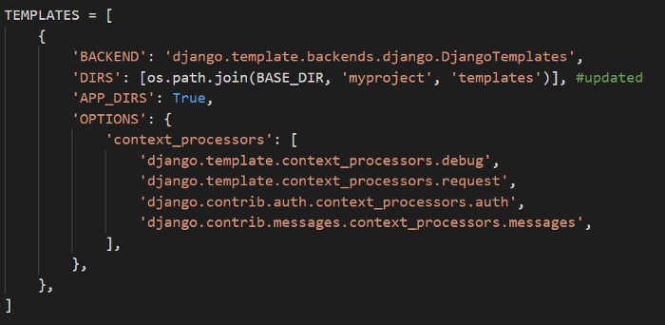
Add parameter LOGIN_REDIRECT_URL in myproject/settings.py
LOGIN_REDIRECT_URL = '/admin'
Step 4: Update urls.py

from django.contrib import admin
from django.urls import path
from django.contrib.auth import views as auth_views #new
urlpatterns = [
path('admin/login/', auth_views.LoginView.as_view(template_name='login.html'), name='login'), #new
path('admin/', admin.site.urls),

]

Step 5: Run server
Run server: python manage.py runserver

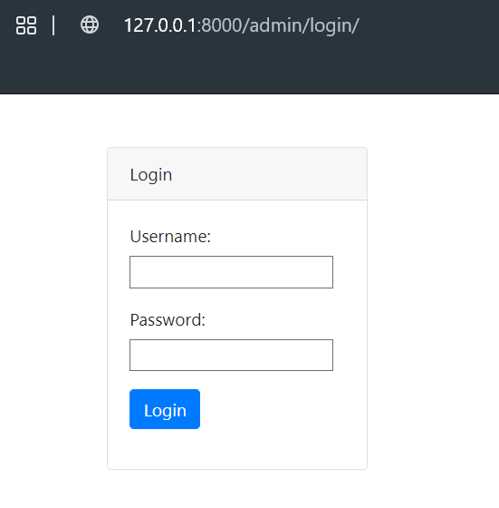

Django Bootstrap Base Template
Simple django bootstrap base template. Official reference for django template and bootstrap.


Step 1: Preparation, Create Django Project, Initial Migration
install virtualenv: pip install virtualenv
create virtualenv: virtualenv venv
start virtualenv: venv/Scripts/activate
install Django in virtualenv: pip install django==3.0
Create Django: django-admin startproject myproject
Go to myproject folder: cd myproject
Migrate: python manage.py migrate
Step 2. Create Django Apps
Create apps: python manage.py startapp myapp
Add myapp to INSTALLED_APPS in myproject/settings.py

Step 3. Preparing Templates Folder
Add folder templates in myapp

Register myapp/templates in myproject/settings.py
os.path.join(BASE_DIR, 'myapp', 'template')

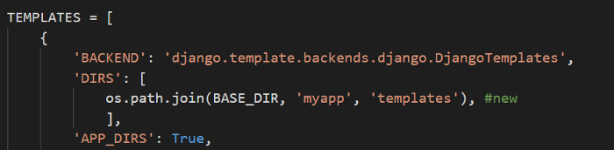
Step 4. Add html file in myapp/templates folder
Add bootstrap base, create base.html …

<html lang="en">
<head>
<title>{% block title %}{% endblock %}</title>
<!-- CSS only -->
<link rel="stylesheet" href="https://stackpath.bootstrapcdn.com/bootstrap/4.5.0/css/bootstrap.min.css"
integrity="sha384-9aIt2nRpC12Uk9gS9baDl411NQApFmC26EwAOH8WgZl5MYYxFfc+NcPb1dKGj7Sk" crossorigin="anonymous">
<!-- JS, Popper.js, and jQuery -->
<script src="https://code.jquery.com/jquery-3.5.1.slim.min.js"
integrity="sha384-DfXdz2htPH0lsSSs5nCTpuj/zy4C+OGpamoFVy38MVBnE+IbbVYUew+OrCXaRkfj"
crossorigin="anonymous"></script>
<script src="https://cdn.jsdelivr.net/npm/popper.js@1.16.0/dist/umd/popper.min.js"
integrity="sha384-Q6E9RHvbIyZFJoft+2mJbHaEWldlvI9IOYy5n3zV9zzTtmI3UksdQRVvoxMfooAo"
crossorigin="anonymous"></script>
<script src="https://stackpath.bootstrapcdn.com/bootstrap/4.5.0/js/bootstrap.min.js"
integrity="sha384-OgVRvuATP1z7JjHLkuOU7Xw704+h835Lr+6QL9UvYjZE3Ipu6Tp75j7Bh/kR0JKI"
crossorigin="anonymous"></script>
</head>
<body>
{% block content %}
{% endblock %}
</body>
</html>

myapp/template/base.html

Create home.html in myapp/templates which implement base.html. Following codes is jumbotron example from official Bootstrap doc.

{% extends 'base.html' %}
{% block title %} Home {% endblock %}
{% block content %}
<nav class="navbar navbar-expand-md navbar-dark fixed-top bg-dark">
<a class="navbar-brand" href="#">Navbar</a>
<button class="navbar-toggler" type="button" data-toggle="collapse" data-target="#navbarsExampleDefault"
aria-controls="navbarsExampleDefault" aria-expanded="false" aria-label="Toggle navigation">
<span class="navbar-toggler-icon"></span>
</button>
<div class="collapse navbar-collapse" id="navbarsExampleDefault">
<ul class="navbar-nav mr-auto">
<li class="nav-item active">
<a class="nav-link" href="#">Home <span class="sr-only">(current)</span></a>
</li>
<li class="nav-item">
<a class="nav-link" href="#">Link</a>
</li>
<li class="nav-item">
<a class="nav-link disabled" href="#" tabindex="-1" aria-disabled="true">Disabled</a>
</li>
<li class="nav-item dropdown">
<a class="nav-link dropdown-toggle" href="#" id="dropdown01" data-toggle="dropdown" aria-haspopup="true"
aria-expanded="false">Dropdown</a>
<div class="dropdown-menu" aria-labelledby="dropdown01">
<a class="dropdown-item" href="#">Action</a>
<a class="dropdown-item" href="#">Another action</a>
<a class="dropdown-item" href="#">Something else here</a>
</div>
</li>
</ul>
<form class="form-inline my-2 my-lg-0">
<input class="form-control mr-sm-2" type="text" placeholder="Search" aria-label="Search">
<button class="btn btn-outline-success my-2 my-sm-0" type="submit">Search</button>

</form>
</div>
</nav>
<main role="main">
<!-- Main jumbotron for a primary marketing message or call to action -->
<div class="jumbotron">
<div class="container">
<h1 class="display-3">Hello, world!</h1>
<p>This is a template for a simple marketing or informational website. It includes a large callout called a
jumbotron and three supporting pieces of content. Use it as a starting point to create something more
unique.</p>
<p><a class="btn btn-primary btn-lg" href="#" role="button">Learn more &raquo;</a></p>
</div>
</div>
<div class="container">
<!-- Example row of columns -->
<div class="row">
<div class="col-md-4">
<h2>Heading</h2>
<p>Donec id elit non mi porta gravida at eget metus. Fusce dapibus, tellus ac cursus commodo, tortor
mauris condimentum nibh, ut fermentum massa justo sit amet risus. Etiam porta sem malesuada magna
mollis euismod. Donec sed odio dui. </p>
<p><a class="btn btn-secondary" href="#" role="button">View details &raquo;</a></p>
</div>
<div class="col-md-4">
<h2>Heading</h2>
<p>Donec id elit non mi porta gravida at eget metus. Fusce dapibus, tellus ac cursus commodo, tortor
mauris condimentum nibh, ut fermentum massa justo sit amet risus. Etiam porta sem malesuada magna
mollis euismod. Donec sed odio dui. </p>
<p><a class="btn btn-secondary" href="#" role="button">View details &raquo;</a></p>
</div>
<div class="col-md-4">
<h2>Heading</h2>
<p>Donec sed odio dui. Cras justo odio, dapibus ac facilisis in, egestas eget quam. Vestibulum id ligula
porta felis euismod semper. Fusce dapibus, tellus ac cursus commodo, tortor mauris condimentum nibh,
ut fermentum massa justo sit amet risus.</p>
<p><a class="btn btn-secondary" href="#" role="button">View details &raquo;</a></p>
</div>
</div>
<hr>
</div> <!-- /container -->
</main>
<footer class="container">
<p>&copy; Company 2017-2020</p>
</footer>
{% endblock %}

myapp/template/home.html

Step 5. Set up views and urls
Add render method in myapp/views.py

from django.shortcuts import render
# Create your views here.
def home(request):
return render(request, "home.html",{})

Create urls.py file in myapp folder

from django.urls import path
from . import views
urlpatterns = [
path('', views.home, name="home"),
]

Add myapp/urls.py to myproject/urls.py using include

from django.contrib import admin
from django.urls import path, include #updated
urlpatterns = [
path('admin/', admin.site.urls),
path('', include('myapp.urls')) #new
]

Step 6. Run and Try it in browser
python manage.py runserver
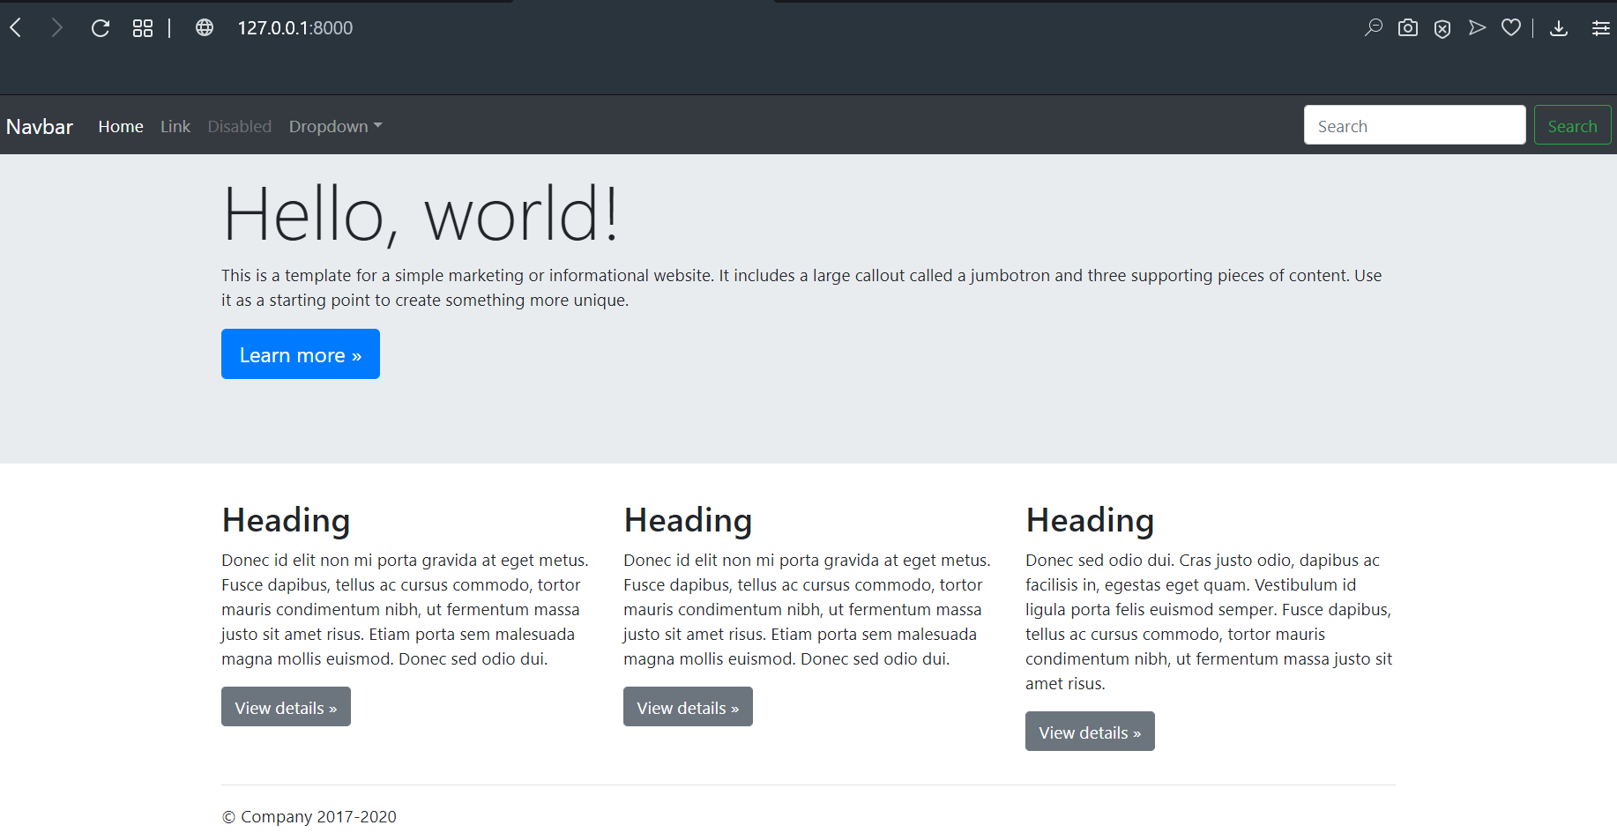
http://127.0.0.1:8000
- Django
- Bootstrap
- Python
- Web Development

Simple Django Rest Framework

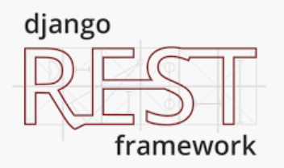
Official django rest framework site here.
Step 1: Preparation
a. Create virtual environtment: virtualenv env
b. Activate virtual environement: venv\Scripts\activate
c. Install django, django rest framwork:
pip install django djangorestframework
Step 2: Create project
a. Create project: django-admin startproject myproject
b. Go to myproject folder: cd myproject
Step 3: Create app
a. Create app: python manage.py startapp myapp
b. Add myapp and djangorestframework in INSTALLED_APPS myproject/settings.py

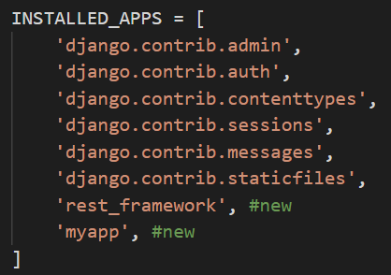
Step 4: Create Model, Serializer and ViewSet
a. Create Model, Serializer and ViewSet in myapp/models.py

from django.db import models
from rest_framework import serializers, viewsets
# Create your models here.
class Book(models.Model):
title = models.CharField(db_column='title', max_length=100, blank=False)
description = models.TextField(db_column='description', max_length=1000, blank=False)
author = models.CharField(db_column='author', max_length=100, blank=False)
year = models.IntegerField(db_column='year',blank=False, default=2000)
class Meta:
db_table = 'book'
verbose_name = 'Book'
verbose_name_plural = 'Books'
def __unicode__(self):
return self.title
def __str__(self):
return self.title
# Serializers define the API representation.
class BookSerializer(serializers.HyperlinkedModelSerializer):
class Meta:
model = Book
fields = ['title', 'description', 'author', 'year']
# ViewSets define the view behavior.
class BookViewSet(viewsets.ModelViewSet):
queryset = Book.objects.all()
serializer_class = BookSerializer

Step 5: Setup URLs
a. Add urls.py in myapp folder. myapp/urls.py

from django.conf.urls import url
from django.urls import include
from rest_framework import routers
from .models import BookViewSet
# Routers provide an easy way of automatically determining the URL conf.
router = routers.DefaultRouter()
router.register(r'book', BookViewSet)
# Additionally, we include login URLs for the browsable API.
urlpatterns = [
url(r'^', include(router.urls)),
url(r'^book/', include('rest_framework.urls', namespace='rest_framework'))
]

b. Update myproject/urls.py

from django.contrib import admin
from django.urls import path, include
urlpatterns = [
path('', include('myapp.urls')),
path('admin/', admin.site.urls),
]

Step 6: Make Migration and Migrate
a. Make migration: python manage.py makemigrations
b. Migrate: python manage.py migrate
Step 7: Run Server
a. Run server: python manage.py runserver
b. Access browser: http://127.0.0.1:8000/

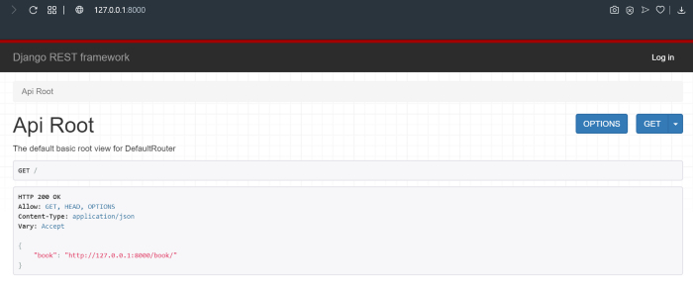
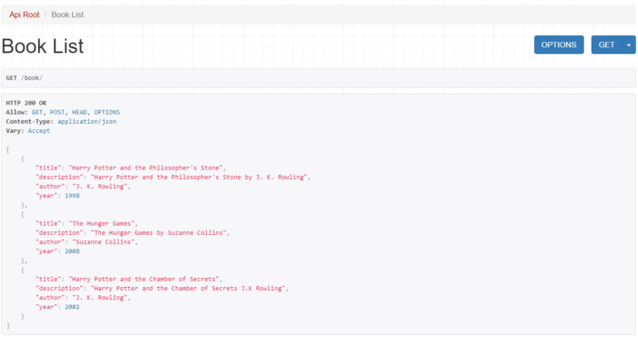

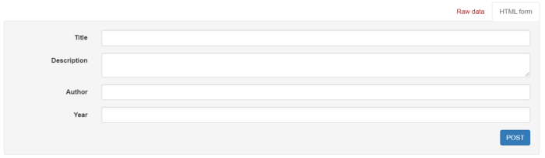

Django Admin Custom Action

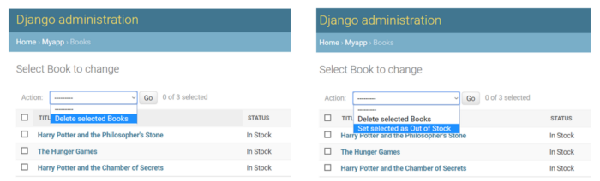
By default, Django admin provide delete model in action. We can add custom action.
Here some quick steps to add custom action.
Step 1: Preparation
a. Create virtualenv and start it.
> virtualenv venv
> venv\Scripts\activate
b. Install Django
(venv)> pip install django
c. Create Django Project
(venv)> django-admin startproject myproject
d. Goto Project Folder and Create Django Application
(venv)> cd myproject
(venv)/ myproject> python manage.py startapp myapp
e. Register Django App to Django Project
add ‘myapp’ in INSTALLED_APPS in myproject/settings.py

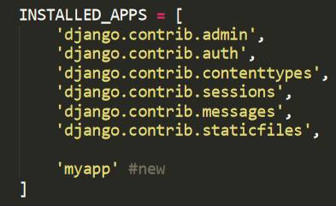
f. Initial Migrate
(venv)/ myproject> python manage.py migrate
g. Create superuser
(venv)/ myproject> python manage.py createsuperuser
type username, email, password and retype password. …
Step 2: Create Book Model
a. Create Book Model
add book model in myapp/models.py

from django.db import models
# Create your models here.
class Book(models.Model):
STATUS_CHOICES = (
('instock','In Stock'),
('outstock','Out of Stock')
)
title = models.CharField(db_column='title', max_length=100, blank=False)
description = models.TextField(db_column='description', max_length=1000, blank=False)
author = models.CharField(db_column='author', max_length=100, blank=False)
year = models.IntegerField(db_column='year',blank=False, default=2000)
status = models.CharField(db_column='status', max_length=50, blank=False, choices=STATUS_CHOICES)
class Meta:
db_table = 'book'
verbose_name = 'Book'
verbose_name_plural = 'Books'
def __unicode__(self):
return self.title
def __str__(self):
return self.title
b. Register model and add custom action
register book model in myapp/admin.py

from django.contrib import admin
from .models import Book
# Register your models here.
class BookAdmin(admin.ModelAdmin):
list_display = ('title', 'status', 'author', 'year', 'description')
actions = ['setOutOfStock', ]
def setOutOfStock(self, request, queryset):
queryset.update(status='outstock')
setOutOfStock.short_description = "Set selected as Out of Stock"
admin.site.register(Book, BookAdmin)
action above will change selected book to ‘Out of Stock’.
c. Make migration and migrate
(venv)/ myproject> python manage.py makemigrations
(venv)/ myproject> python manage.py migrate
Step 3: Start Apps
(venv)/ myproject> python manage.py runserver
open http://127.0.0.1:8000/admin open Book menu and add some book data and do some test with new custom action.

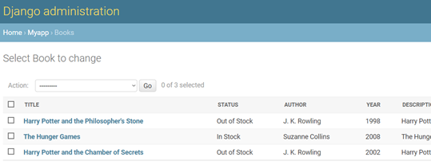
- Django
- Python
- Web Development

Django Admin Add Search Field
Basic search field in Django Admin.
Start with this admin app (Book ModelAdmin). To create from the start refer this link.

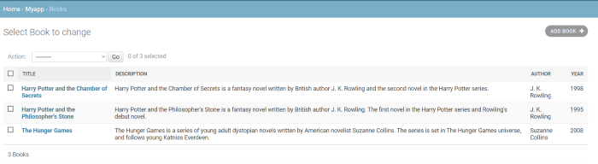
Add search_field in class BookAdmin. Example: search by title and author.
search_fields = ['title', 'author']
admin.py

from django.contrib import admin
from .models import Book
# Register your models here.
class BookAdmin(admin.ModelAdmin):
list_display = ('title', 'description', 'author', 'year')
search_fields = ['title', 'author']
admin.site.register(Book, BookAdmin)

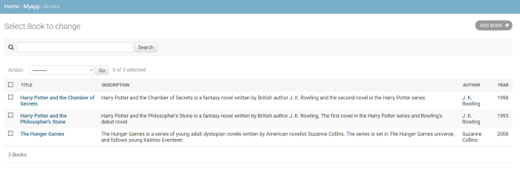

Django Apps with PostgreSQL Database


Summarized section in the end of article.
Step 1. Preparation
install virtualenv: pip install virtualenv
create virtualenv: virtualenv venv
start virtualenv: venv/Scripts/activate
install Django and pysoppg2 in virtualenv: pip install django psycopg2
Step 2. Create Django Project
Create Django: django-admin startproject myproject
Go to myproject folder: cd myproject
Step 3. Set Up Database Connection
By default django provide sqlite database and connections. We need to change it to postgresql. Asumption, postgresql database is ready to be connected.
Update project_folder/settings.py
DATABASES = {'default':
{'ENGINE': 'django.db.backends.postgresql_psycopg2',
'NAME': 'database_name',
'USER': 'database_user',
'PASSWORD': 'database_pass',
'HOST': 'localhost',
'PORT': '5432',
}
}
Step 4. Initial Migrations
Migrate Django: python manage.py migrate
This command will generate some initial tables in postgresql database.

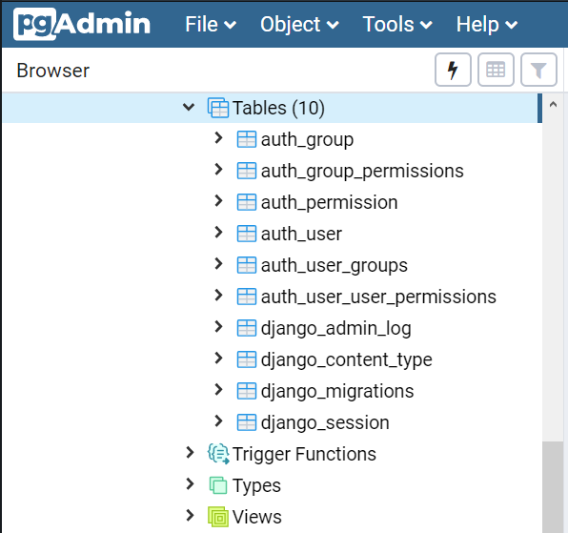
Step 5. Run Server
Run Django: python manage.py runserver

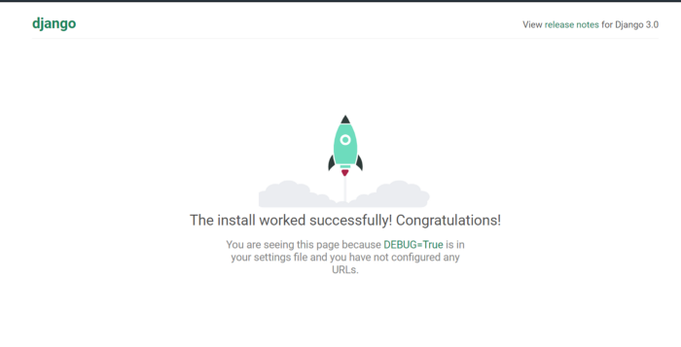
Summarized section
Update project_folder/settings.py
DATABASES = {'default':
{'ENGINE': 'django.db.backends.postgresql_psycopg2',
'NAME': 'database_name',
'USER': 'database_user',
'PASSWORD': 'database_pass',
'HOST': 'localhost',
'PORT': '5432',
}
}

Start New Django Project
Windows, Python 3.x, Django 3.0, in virtual environment.
Summarized section in the end of article.
Step 1: Preparation:
a. Install python, python official download here.
b. Install python virtualenv using pip.
...> pip install virtualenv
c. Create virtualenv
...> virtualenv venv

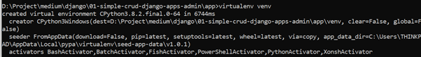
d. Start virtualenv
...> venv\Scripts\activate

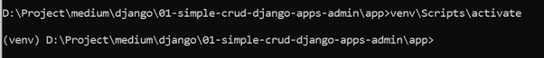
e. Install django
(venv)...> pip install django==3.0

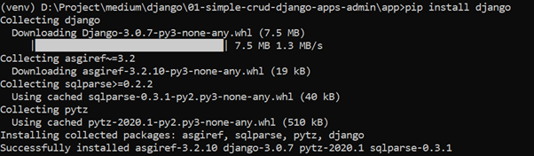
Step 2: Create Django Project
a. Create django project
(venv)...> django-admin startproject myproject
b. Go to myproject folder
(venv)...> cd myproject
c. Run django
(venv).../myproject> python manage.py runserver

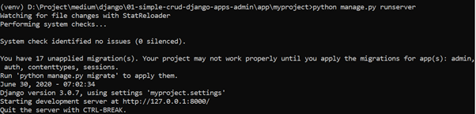
site url: http://127.0.0.1:8000

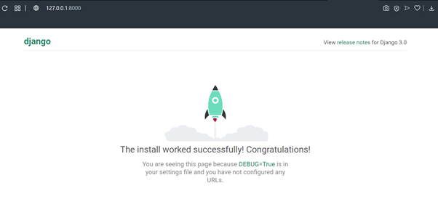
d. To stop server, use CRTL+C key
Step 3: Initial Migration
a. Migrate
(venv).../myproject> python manage.py …

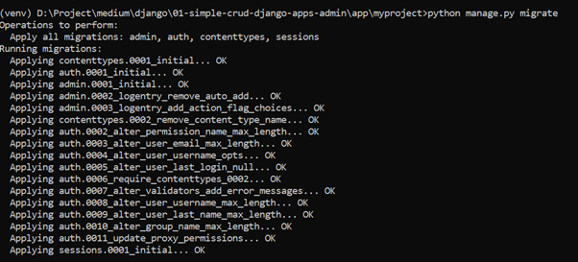
Step 4: Create superuser
a. create superuser
(venv).../myproject> python manage.py createsuperuser

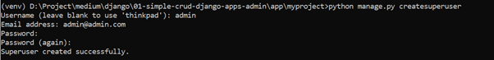
then type username, email, password and password confirmation.
admin site: http://127.0.0.1:8000/admin

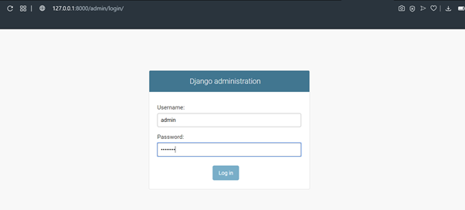

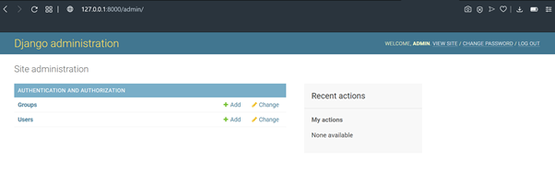
Summarized Section:
Step 1. Preparation
install virtualenv: pip install virtualenv
create virtualenv: virtualenv venv
start virtualenv: venv/Scripts/activate
install Django in virtualenv: pip install django
Step 2. Create Django Project
Create Django: django-admin startproject myproject
Go to myproject folder: cd myproject
Run Django: python manage.py runserver
Access: http://127.0.0.1:8000
Step 3. Initial Migration
Migrate: python manage.py migrate
Step 4. Superuser
Create superuser: python manage.py createsuperuser
Admin access: http://127.0.0.1:8000/admin

Modify Title and Header Django Admin Interface


Small customization django admin site. Oficial doc here.
Jump to summarized section in the end of the article for short version.
Modify Site Header

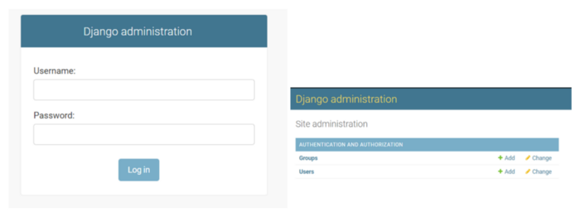
add code below in project_folder/urls.py
from django.contrib import admin
admin.site.site_header = 'Book List Administration'

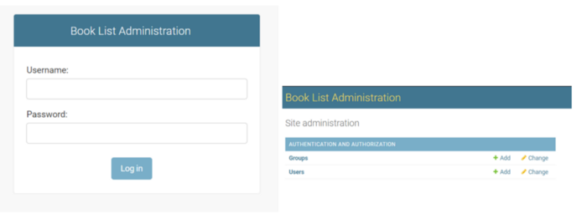
Modify Site Title
add code below in project_folder/urls.py
from django.contrib import admin
admin.site.site_title = 'Book Site'

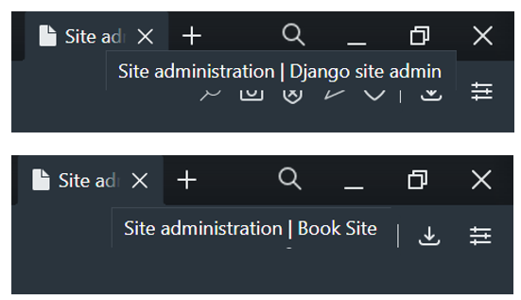
Modify Index Title “Site Administration”
add code below in project_folder/urls.py
from django.contrib import admin
admin.site.index_title= 'Book Site Administration'

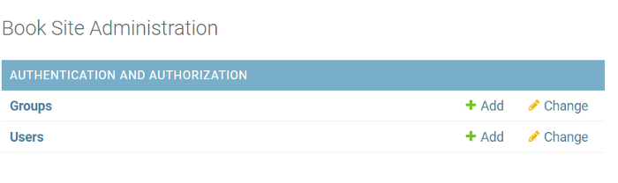
Modify Site URL
By default Django Admin interface provides “View site” link and redirect to “/” or http://127.0.0.1:8000/ for local default. We can change to other urls, /admin for example by add code below in project_folder/urls.py.
from django.contrib import admin
admin.site.site_url= '/admin'

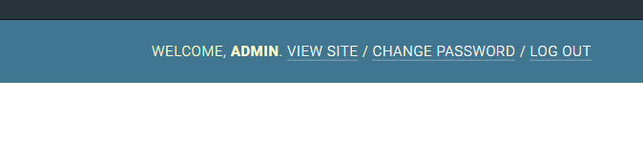
Summarized Section
add code below project_folder/urls.py.
#Modify Site Header
admin.site.index_title = ‘Book List Administration’
#Modify Site Title
admin.site.site_title = ‘Book Site’
#Modify Site Index Title
admin.site.index_title = ‘Book Site Administration’
#Modify Site URL
admin.site.site_urls= ‘/admin’

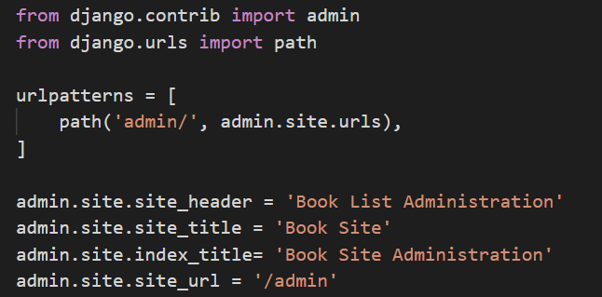

How I Create Django Admin CRUD Apps

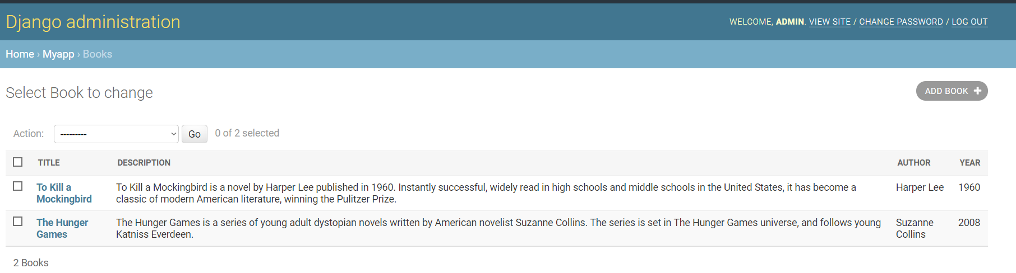Spoiler: This is long read article, jump to Summarized Section in the end of article to read short version.
Step 1: Preparation:
I use python 3.8 in windows when writing this article. For installation instruction, you can read the official python installation document in this link.
check python version: python — version

Install python virtualenv: pip install virtualenv
create virtual environment: virtualenv env

activate virtual env: venv\Scripts\activate

Install Django in virtual environment: pip install django

Step 2: Create Django Project
create project: django-admin startproject myproject
This command will create a Django myproject folder with its generated folders and files.
Go to myproject folder: cd myproject
Start Django: python manage.py runserver

Try to access http://127.0.0.1:8000 in browser

Step 3: Initial Migration
Migrate is a step to generate database (by default django use sqlite database) and some tables. For initial, Django provides great initial tables for us. In previous step there is warning “You have 17 unapplied migration(s) … . Run ‘python manage.py runserver’ to apply them.” Let’s try to apply.
migrate: python manage.py migrate

We can restart apps and no more migration warning and django admin site is installed. Try to access admin site: http://127.0.0.1:8000/admin

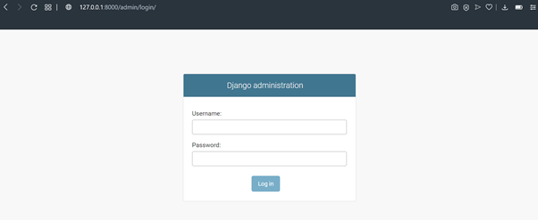
Step 4: Superuser
Create superuser: python manage.py createsuperuser

Type username, email and password.
Try to login in Django admin with superuser

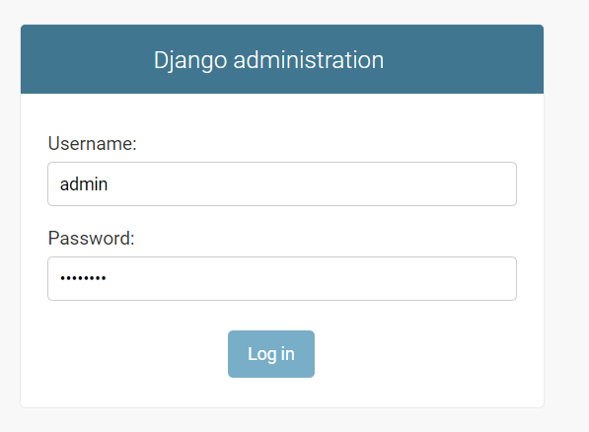

In this state we can explore django admin site with built-in menu (include authorization and authentication).
Step 5: Create Application
Create app: python manage.py startapp myapp
this command will generate myapp folder and some files.
Open myproject folder in text editor. I use VS Code. alternatives: Sublime, Atom, Notepad++.

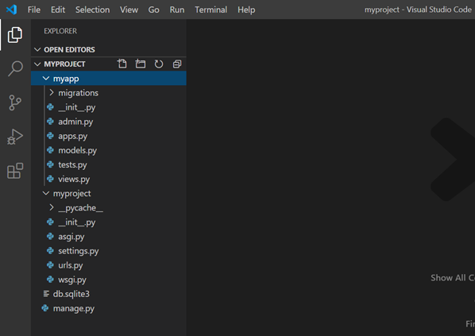
Create new model in myapp/models.py

from django.db import models
# Create your models here.
class Book(models.Model):
title = models.CharField(db_column='title', max_length=100, blank=False)
description = models.TextField(db_column='description', max_length=1000, blank=False)
author = models.CharField(db_column='author', max_length=100, blank=False)
year = models.IntegerField(db_column='year',blank=False, default=2000)
class Meta:
db_table = 'book'
verbose_name = 'Book'
verbose_name_plural = 'Books'
def __unicode__(self):
return self.title
def __str__(self):
return self.title

Register model in admin myapp/admin.py

from django.contrib import admin
from .models import Book
# Register your models here.
class BookAdmin(admin.ModelAdmin):
list_display = ('title', 'description', 'author', 'year')

admin.site.register(Book, BookAdmin)

Add myapp in INSTALLED_APPS in myproject/settings.py

Make migrations: python manage.py makemigrations

Migrate: python manage.py migrate

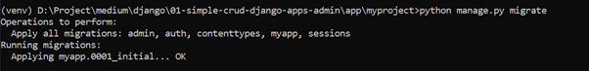
Run server and try to access admin site. Books menu now can be accessed in admin site.

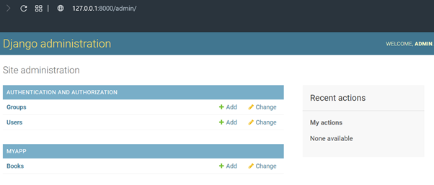
Open Books menu in MYAPP and do some cool operation like Add, Edit, Delete.

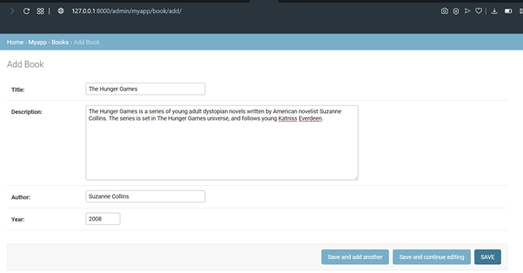

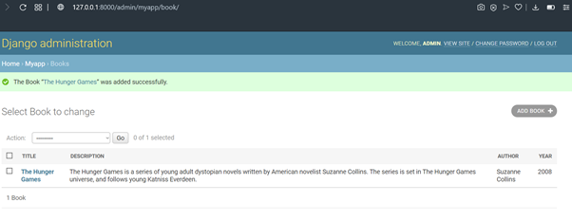
Summarized Section:
Step 1. Preparation
install virtualenv: pip install virtualenv
create virtualenv: virtualenv venv
start virtualenv: venv/Scripts/activate
install Django in virtualenv: pip install django
Step 2. Create Django Project
Create Django: django-admin startproject myproject
Go to myproject folder: cd myproject
Run Django: python manage.py runserver
Access: http://127.0.0.1:8000
Step 3. Initial Migration
Migrate: python manage.py migrate
Step 4. Superuser
Create superuser: python manage.py createsuperuser
Admin access: http://127.0.0.1:8000/admin
Step 5. Create Application
Create app: python manage.py startapp myapp
Create model: add model in myapp/models.py
Create modeladmin: add modeladmin in myapp/admin.py
Register app: add myapp in INSTALLED_APP in myproject/settings.py
Make migrations: python manage.py makemigrations
Migrate: python manage.py migrate
Run server: python manage.py runserver

